PROJECT TITLE:BOLTS AND WASHERS

# ARDUINO CODE SCREENSHOTS.

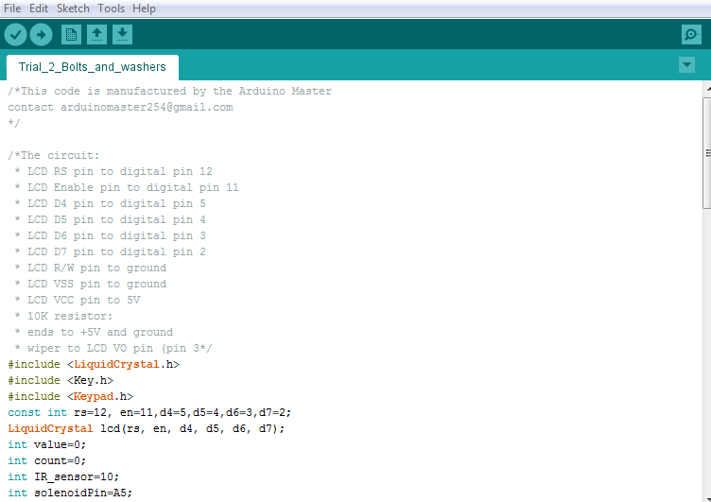

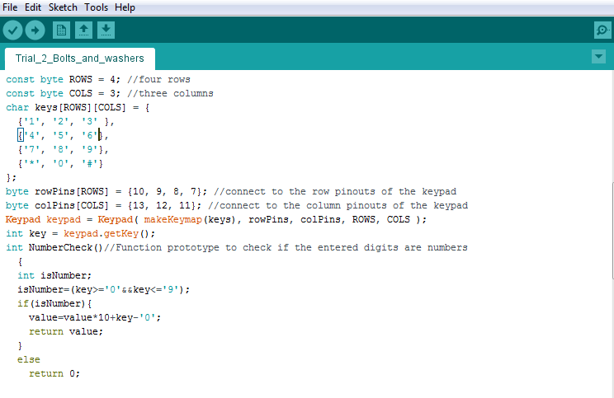

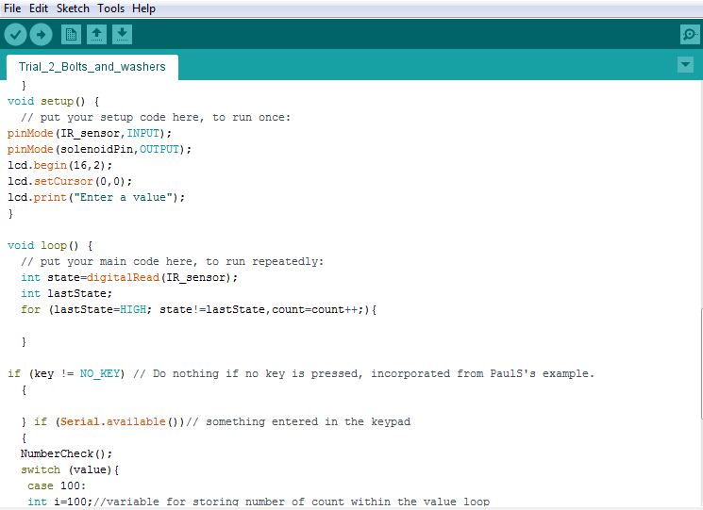

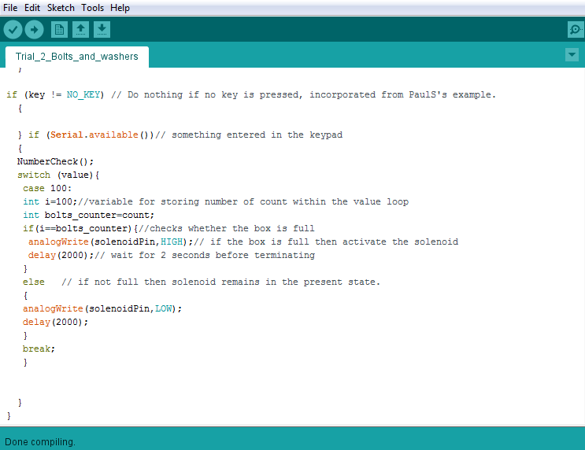

# ARDUINO CODE IN PLAIN TEXT

/*This code is manufactured by the Arduino Master

contact arduinomaster254@gmail.com

*/

/*The circuit:

* LCD RS pin to digital pin 12

* LCD Enable pin to digital pin 11

* LCD D4 pin to digital pin 5

* LCD D5 pin to digital pin 4

* LCD D6 pin to digital pin 3

* LCD D7 pin to digital pin 2

* LCD R/W pin to ground

* LCD VSS pin to ground

* LCD VCC pin to 5V

* 10K resistor:

* ends to +5V and ground

* wiper to LCD VO pin (pin 3*/

#include <LiquidCrystal.h>

#include <Key.h>

#include <Keypad.h>

const int rs=12, en=11,d4=5,d5=4,d6=3,d7=2;

LiquidCrystal lcd(rs, en, d4, d5, d6, d7);

int value=0;

int count=0;

int IR_sensor=10;

int solenoidPin=A5;

const byte ROWS = 4; //four rows

const byte COLS = 3; //three columns

char keys[ROWS][COLS] = {

{'1', '2', '3' },

{'4', '5', '6'},

{'7', '8', '9'},

{'*', '0', '#'}

};

byte rowPins[ROWS] = {10, 9, 8, 7}; //connect to the row pinouts of the keypad

byte colPins[COLS] = {13, 12, 11}; //connect to the column pinouts of the keypad

Keypad keypad = Keypad( makeKeymap(keys), rowPins, colPins, ROWS, COLS );

int key = keypad.getKey();

int NumberCheck()//Function prototype to check if the entered digits are numbers

{

int isNumber;

isNumber=(key>='0'&&key<='9');

if(isNumber){

value=value*10+key-'0';

return value;

}

else

return 0;

}

void setup() {

// put your setup code here, to run once:

pinMode(IR_sensor,INPUT);

pinMode(solenoidPin,OUTPUT);

lcd.begin(16,2);

lcd.setCursor(0,0);

lcd.print("Enter a value");

}

void loop() {

// put your main code here, to run repeatedly:

int state=digitalRead(IR_sensor);

int lastState;

for (lastState=HIGH; state!=lastState,count=count++;){

}

if (key != NO_KEY) // Do nothing if no key is pressed, incorporated from PaulS's example.

{

} if (Serial.available())// something entered in the keypad

{

NumberCheck();

switch (value){

case 100:

int i=100;//variable for storing number of count within the value loop

int bolts_counter=count;

if(i==bolts_counter){//checks whether the box is full

analogWrite(solenoidPin,HIGH);// if the box is full then activate the solenoid

delay(2000);// wait for 2 seconds before terminating

}

else // if not full then solenoid remains in the present state.

{

analogWrite(solenoidPin,LOW);

delay(2000);

}

break;

}

}

}